**DIGITAL NURTURE 4.0 DEEP SKILLING JAVA FSE-WEEK1**

**NAME: SIVITHA GUNASEKARAN**

**SUPERSET ID: 6413354**

**WEEK 1: DESIGN PATTERNS AND PRINCIPLES**

**Exercise 6: Library Management System**

**Scenario:**

You are developing a library management system where users can search for books by title or author.

**Steps:**

1. **Understand Search Algorithms:**
   * Explain linear search and binary search algorithms.
2. **Setup:**
   * Create a class **Book** with attributes like **bookId**, **title**, and **author**.
3. **Implementation:**
   * Implement linear search to find books by title.
   * Implement binary search to find books by title (assuming the list is sorted).
4. **Analysis:**
   * Compare the time complexity of linear and binary search.
   * Discuss when to use each algorithm based on the data set size and order.

**CODE SAMPLES:**

**DecoratorPatternExample.java**

interface Notifier {

void send();

}

class EmailNotifier implements Notifier {

public void send() {

System.out.println("Sending Email Notification");

}

}

abstract class NotifierDecorator implements Notifier {

protected Notifier notifier;

public NotifierDecorator(Notifier notifier) {

this.notifier = notifier;

}

public void send() {

notifier.send();

}

}

class SMSNotifierDecorator extends NotifierDecorator {

public SMSNotifierDecorator(Notifier notifier) {

super(notifier);

}

public void send() {

super.send();

System.out.println("Sending SMS Notification");

}

}

class SlackNotifierDecorator extends NotifierDecorator {

public SlackNotifierDecorator(Notifier notifier) {

super(notifier);

}

public void send() {

super.send();

System.out.println("Sending Slack Notification");

}

}

public class DecoratorPatternExample {

public static void main(String[] args) {

Notifier baseNotifier = new EmailNotifier();

Notifier smsDecorator = new SMSNotifierDecorator(baseNotifier);

Notifier slackAndSmsDecorator = new SlackNotifierDecorator(smsDecorator);

slackAndSmsDecorator.send();

}

}

**OUTPUT:**

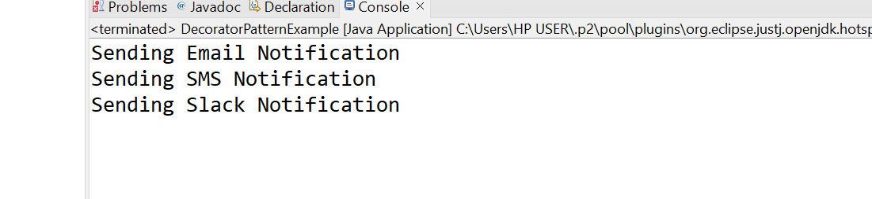

**MY SCREENSHOT PROOFS:**

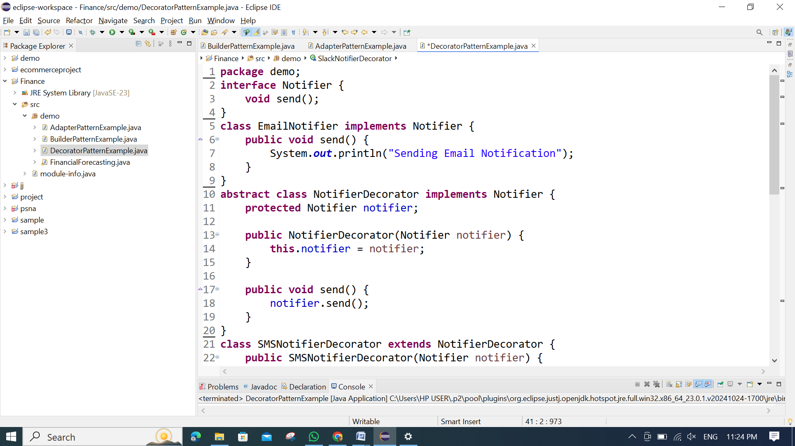

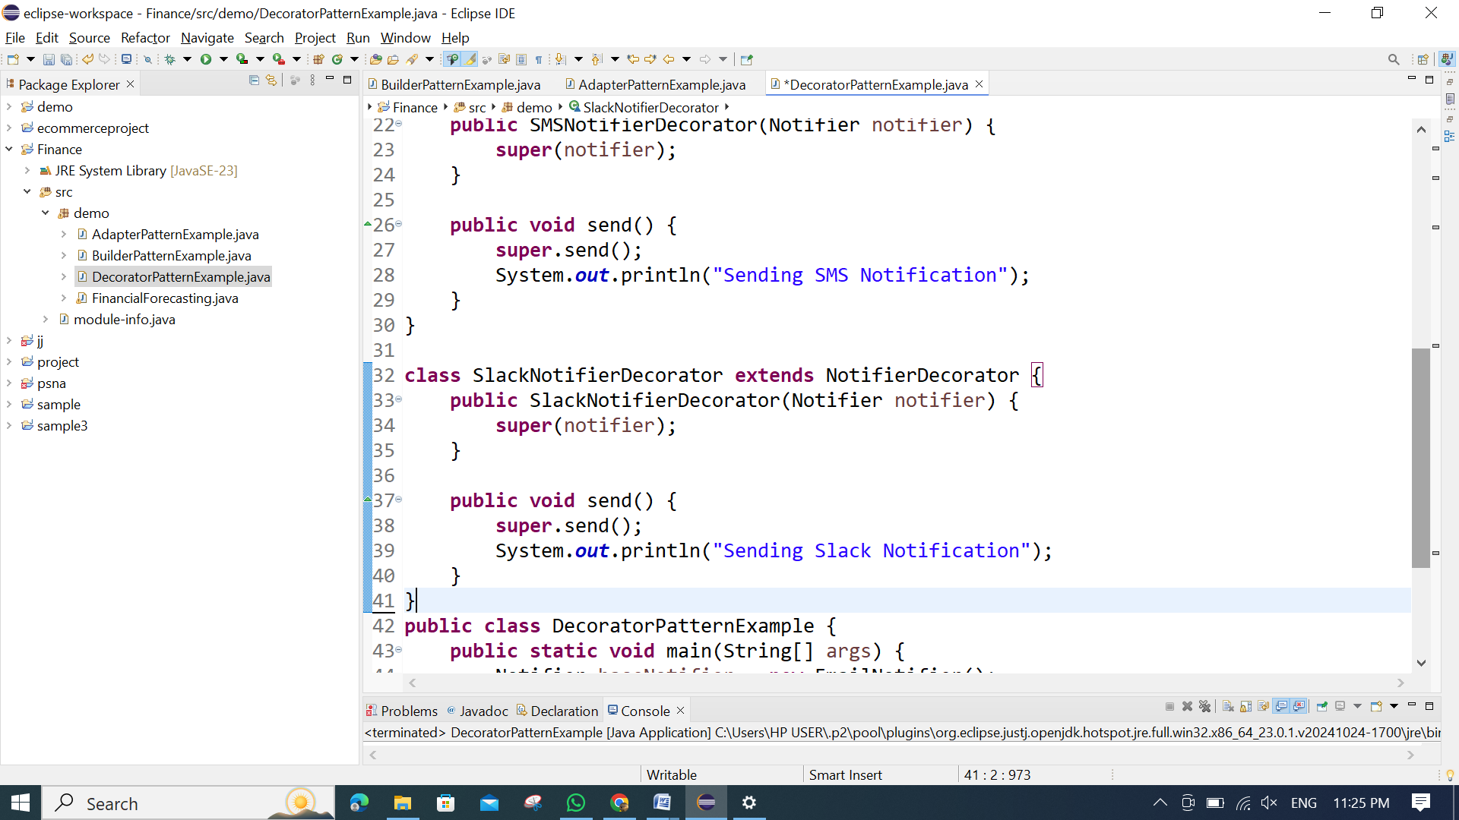

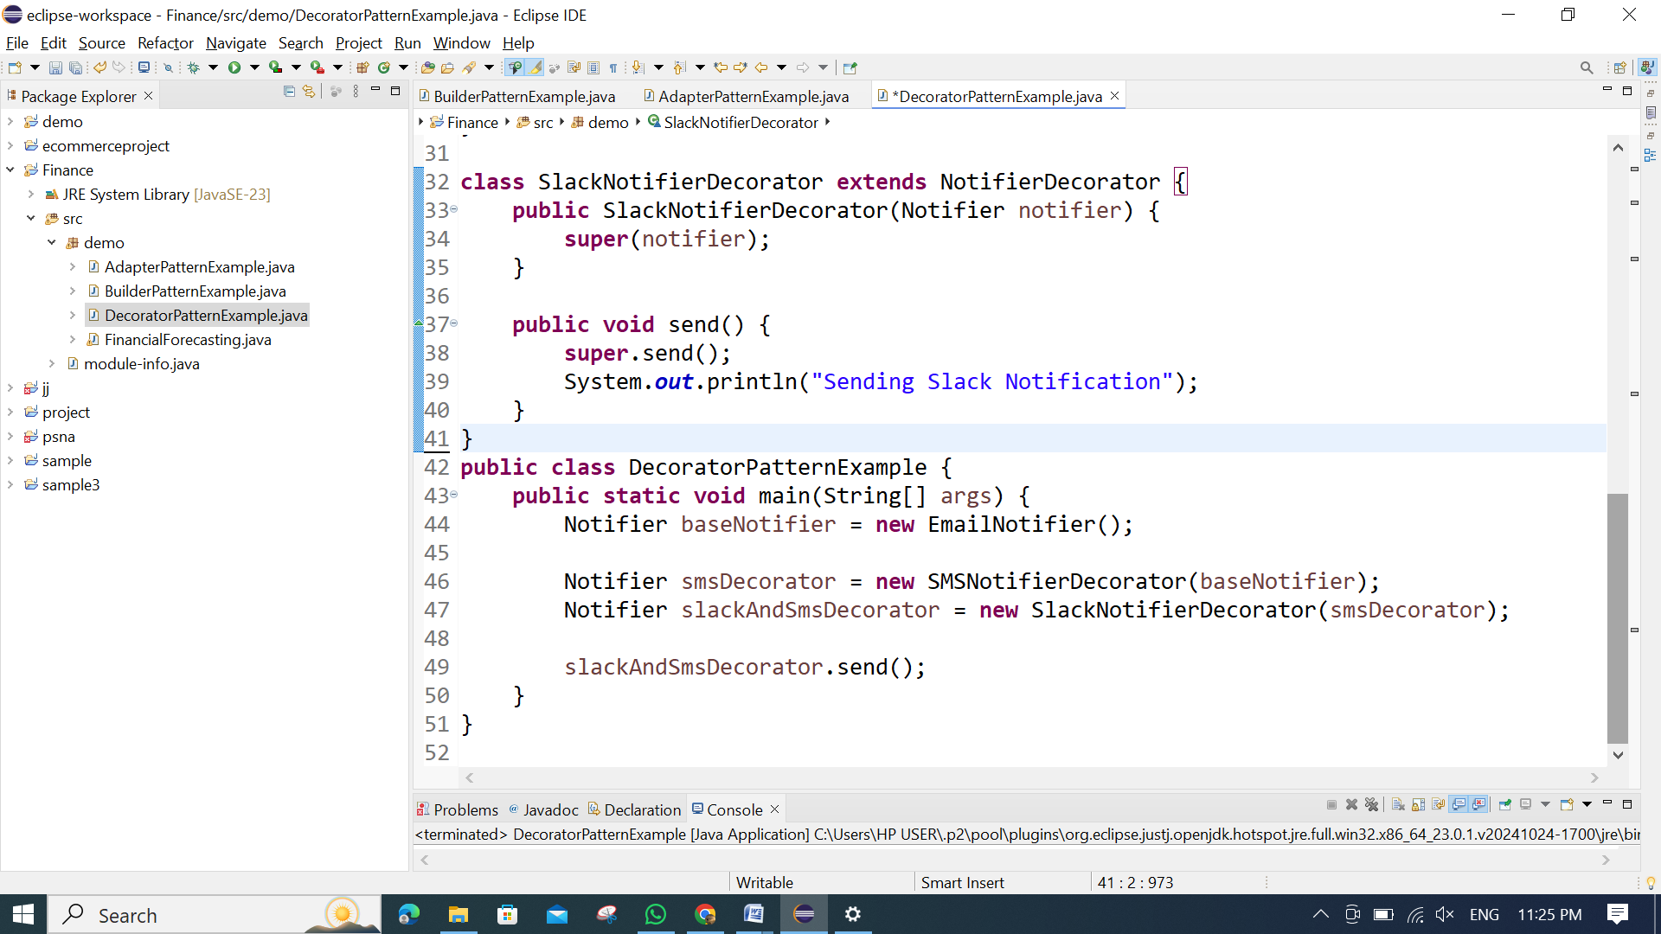

**OUTPUT:**

